### Aim/objective:

To find the rate of infiltration or the rate at which water enters in soil.

Material required:

1. Double ring infiltrometer (diameter of the inner ring is 30 cm & outer ring is 60 cm)
2. Hammer
3. Water level indicator
4. Stopwatch
5. Water

|  |
| --- |
|  |
|  |

Theory

Infiltration is the process of entering water from ground surface into soil surface. As the precipitation reaches the ground surface firstly it wets down the soil to reach its moisture level later it starts to penetrate into the soil surface in the form of infiltration after meeting the surface soil moisture conditions. The excess water penetrates downwards under the action of gravity into the soil subsurface , this process is known as percolation. The rate at which the infiltrated water is observed by the soil is known as the “infiltration rate”. The infiltration rate is dependent on various factors: land cover ( vegetation), soil type, hydraulic conductivity, texture, structure. Different soils have different infiltration rates hence infiltration plays an important role in generation of runoff. Runoff is the overflow of accumulated water on the surface exceeding the infiltration rate. Whenever the infiltration rate of particular soil is less than the intensity of rainfall at the given time, it results in a higher rate of surface runoff. In addition the different soil conditions have different rate of infiltration, compacted soil due to agricultural activity, human movement have lower rate of infiltration, whereas natural vegetated land has higher infiltration rate. The infiltration is usually higher at the beginning and slows down exponentially with time and reaches a constant rate. During rainy days the infiltration rate will be higher on the first day of precipitation due to dry soil condition, later it decreases day by day due to soil saturation.

The infiltration rate is measured as depth of water infiltrated in measured time, usually expressed in mm/min, cm/hour. For a given soil the maximum rate at which the water can infiltrate into soil under given conditions is called the infiltration capacity of the soil. And the total depth of water infiltrated in a given period of time under given conditions is called as accumulated infiltration. and is expressed in cm units. Usually the infiltration rate is measured in the field using a cylindrical infiltrometer. There are two types of infiltrometers: single ring and double ring infiltrometers. The double ring infiltrometer has metallic inner and outer rings of diameter of 30 and 60 cm respectively with a minimum height of 25 cm. These rings are driven into the soil up to 10 cm depth of soil. Then both the rings are filled with water upto marked levels. The purpose of using two rings instead of one is that the water which flows from the outer ring acts to prevent the lateral flow of the water from the inner ring. Consequently, water infiltration is measured from the inner ring to the vertical (downward) flow only. Once infiltration starts the change in water levels are measured and noted down at particular time intervals. Once the infiltration rate reaches the constant rate experiment is stopped.

Hortno’s equation is a commonly used empirical equation to calculate the infiltration capacity of soil.

fp =+ (-)

Where,

*fp*= the infiltration capacity at some time t(depth/time)

*k* = a Horton’s decay coefficient constant representing the rate of decrease in f capacity.

*f*c = a final steady state infiltration capacity t=tc

*f*o = the initial infiltration capacity at t=0

Pre-test self assessment

1. infiltration rate is always

1. more than the infiltration capacity
2. less than the infiltration capacity
3. equal to or less than the infiltration capacity
4. equal to or more than the infiltration capacity

**Answer - C**

2. What is the process by which water enters the small pore spaces between particles in soil or rocks

1. Transpiration
2. Infiltration
3. Precipitation
4. Sublimation

**Answer - B**

3. The infiltration capacity of a soil depends upon

1. Number of voids present in the soil
2. Shape and size of soil particles
3. Arrangement of soil particles & compaction of the soil particles
4. All the above

**Answer - D**

4. The infiltration of water into the subsurface is the ________ .

1. Influent
2. Effluent
3. Discharge
4. Recharge

**Answer - D**

5. Infiltration Capacity

1. Is a constant factor
2. Changes with time
3. Changes with location
4. Changes with both time and location

**Answer- D**

Inkscape images- (as per numerical order)

<https://www.youtube.com/watch?v=PYvfTxQhbOQ&t=43s>

Video reference for person doing inkscaping for better understanding( if at all required)

Select the field for in situ test

| 1)Grassland | 2)Barren ground |
| --- | --- |
|  |  |

1. Place the inner ring and hammer the inner ring of the Double ring infiltrometer into the soil using a driving plate.

|  |
| --- |
| [Copy of drawing2.1.png](https://drive.google.com/open?id=1omeQ_4yyPqpPH8MvLn0hcXVx3C82Ze6p&usp=drive_copy) |
|  |
|  |
|  |

Pop up question:

For infiltration test the land should be—---

1. Sloping
2. **Plain**

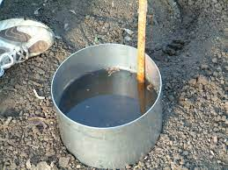

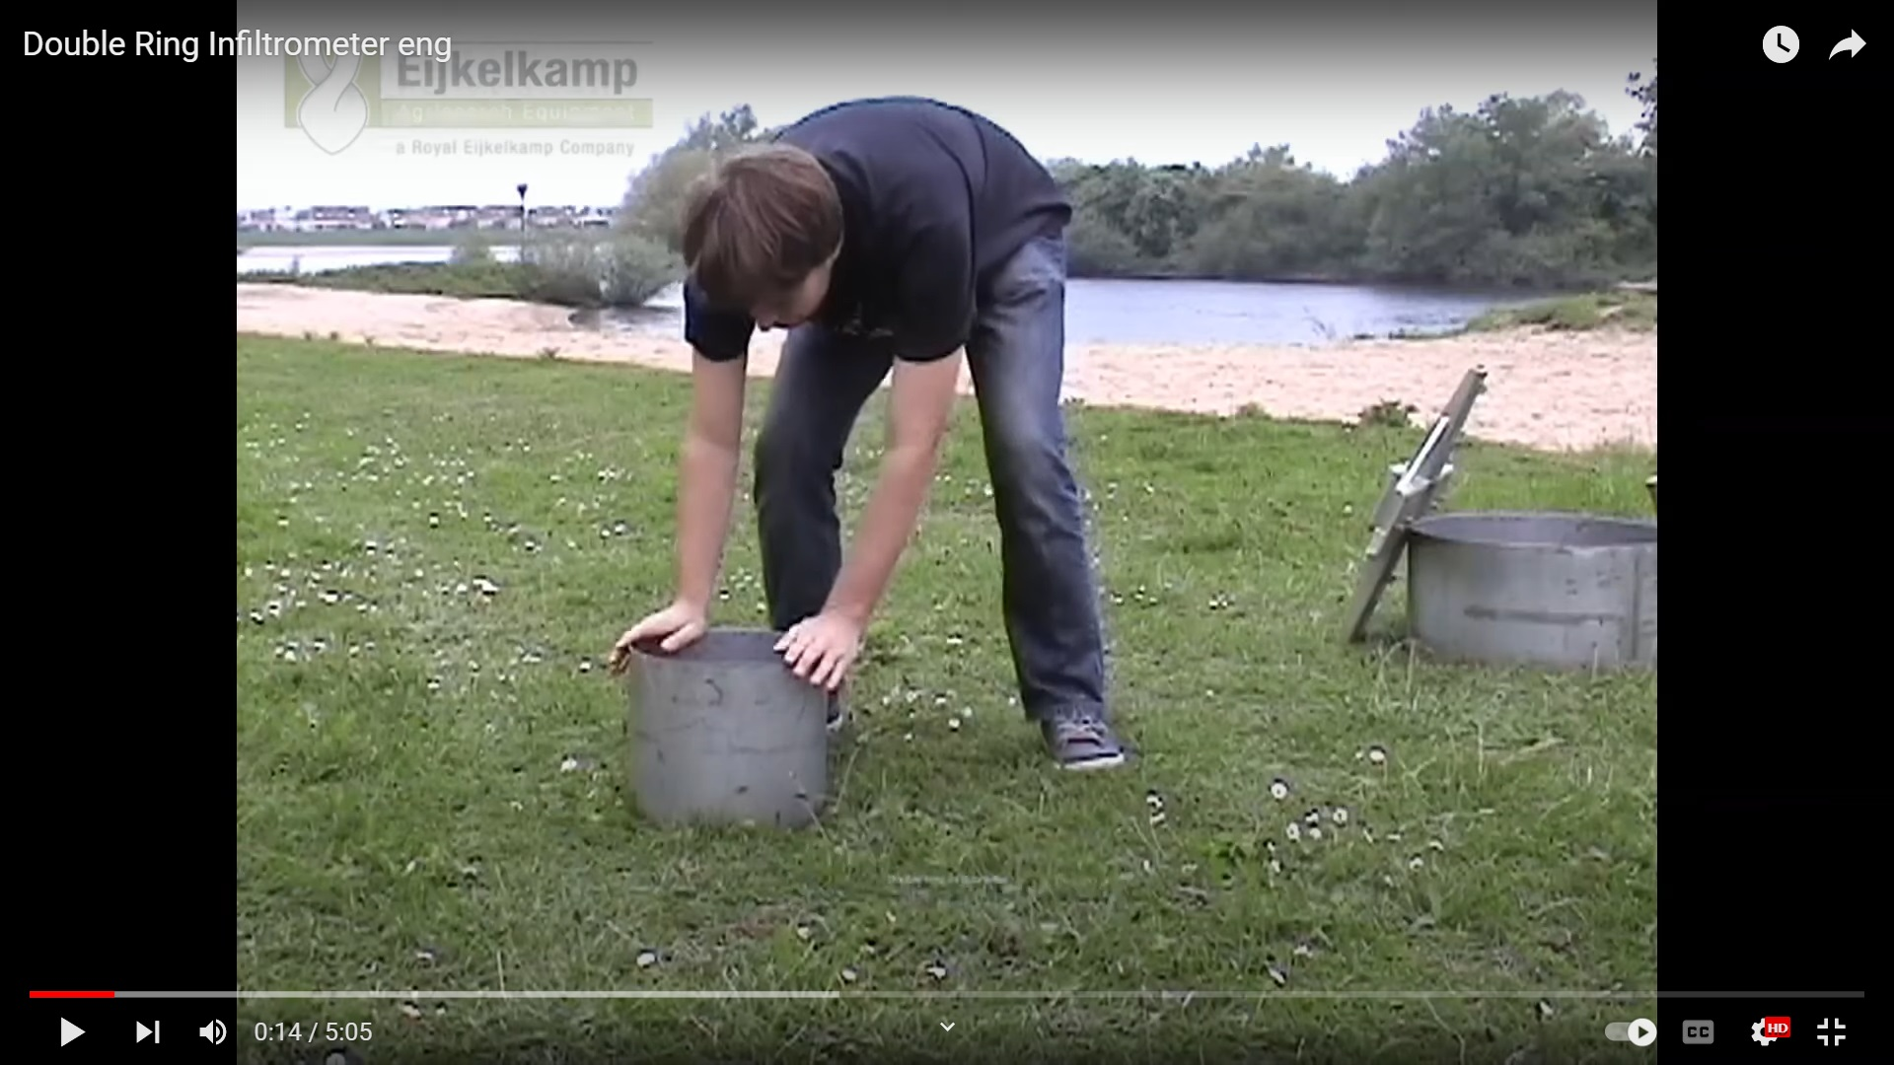

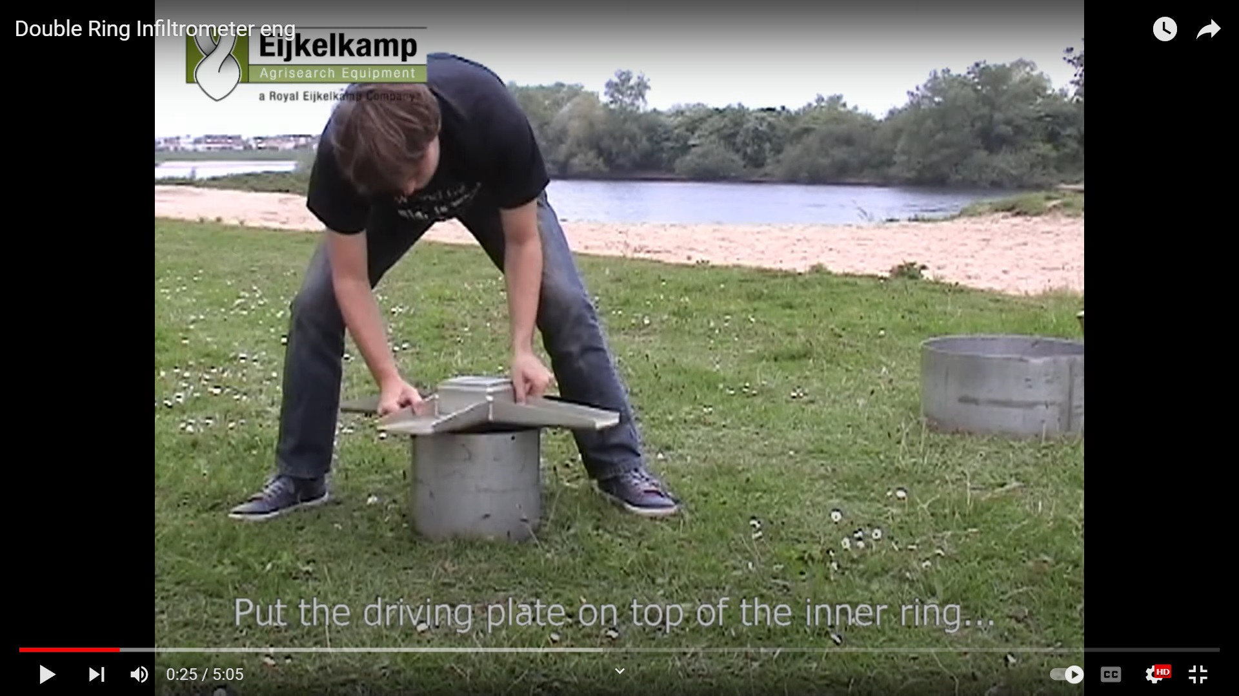

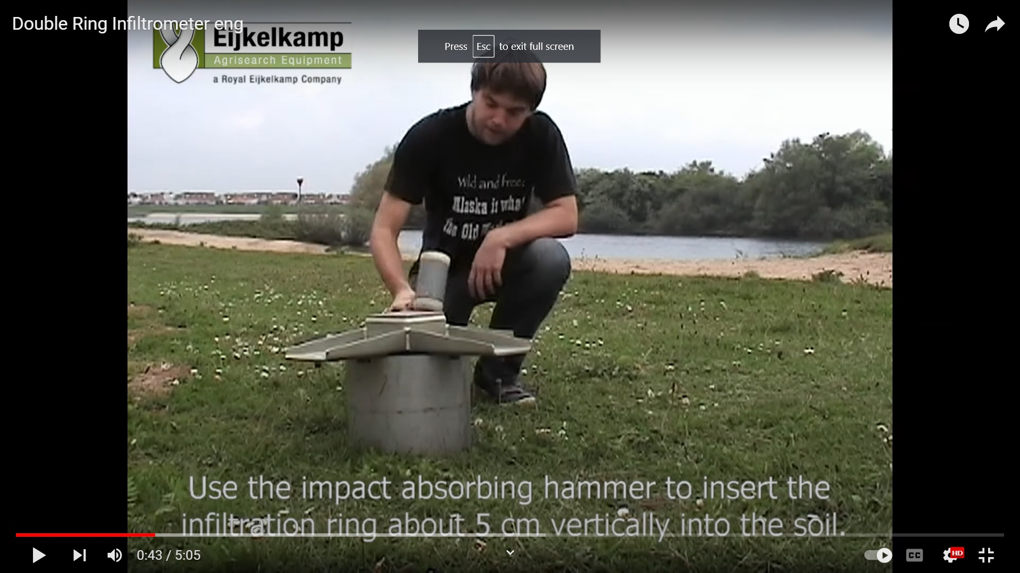

1. Place the outer ring of the Double ring infiltrometer and hammer the outer ring into the soil. Care should be taken cause minimum disturbance to the soil

|  |
| --- |
|  |
|  |
|  |
|  |
|  |

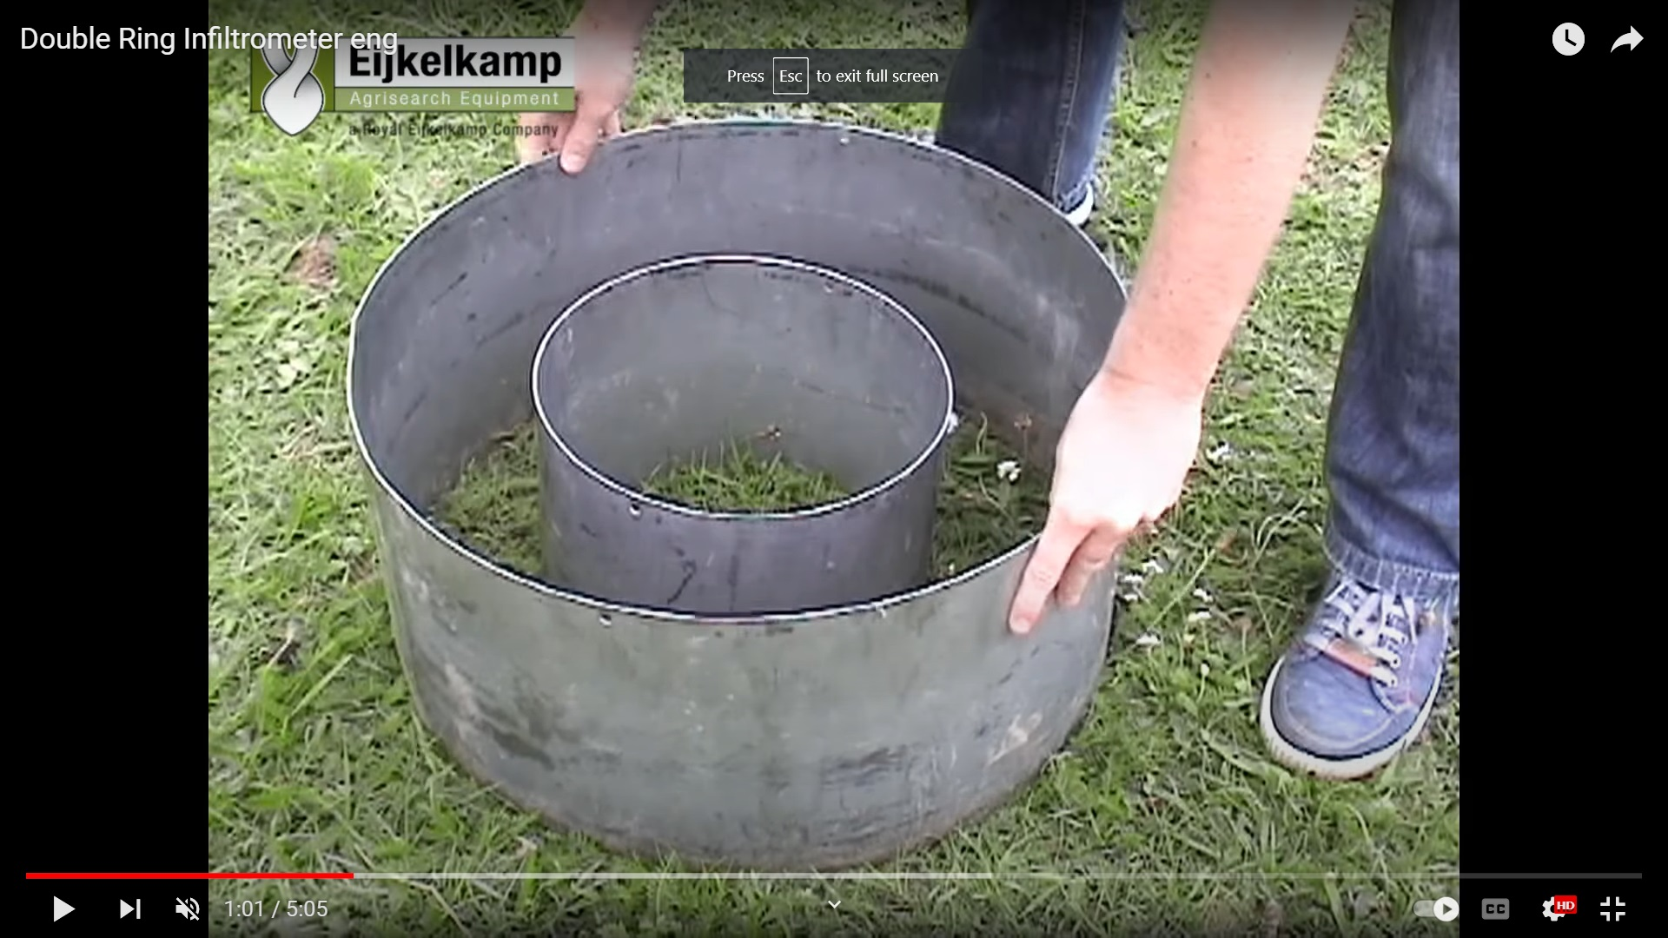





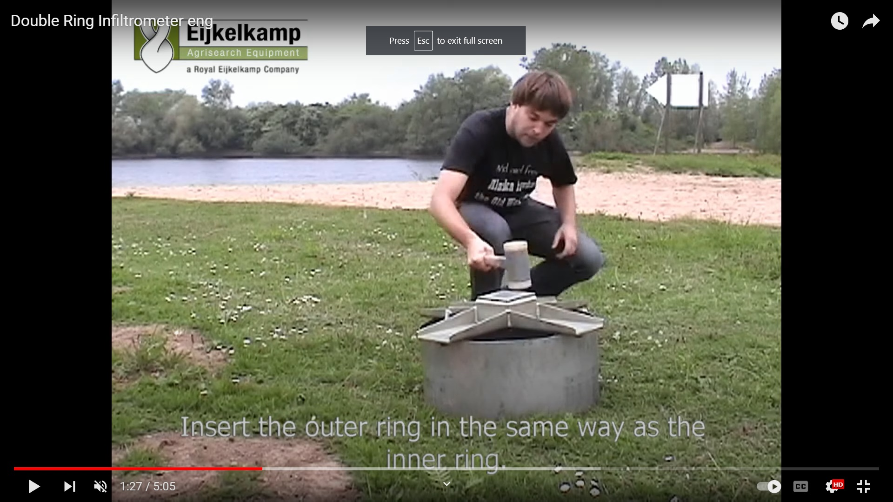

3) place the water level indicator inside the inner ring to note down the readings of water level.

|  |
| --- |
|  |
|  |
|  |
|  |
|  |

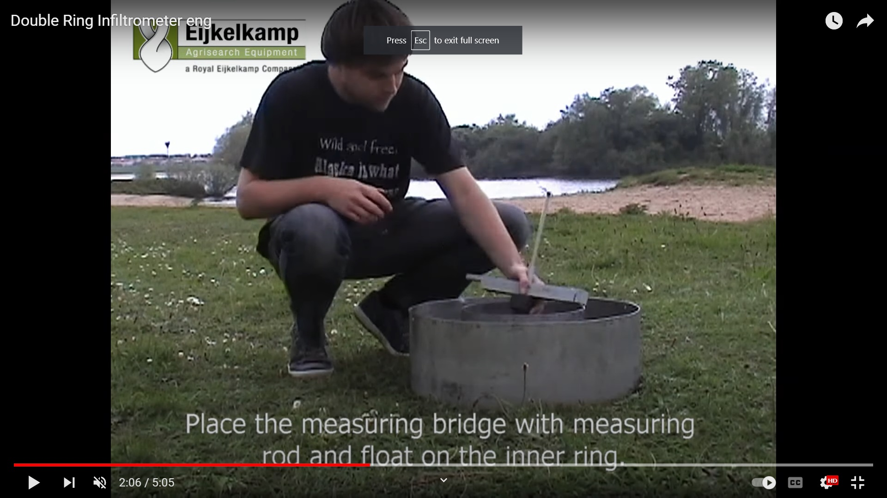

4) fill inner and outer rings with water and maintain equal water level in both rings. 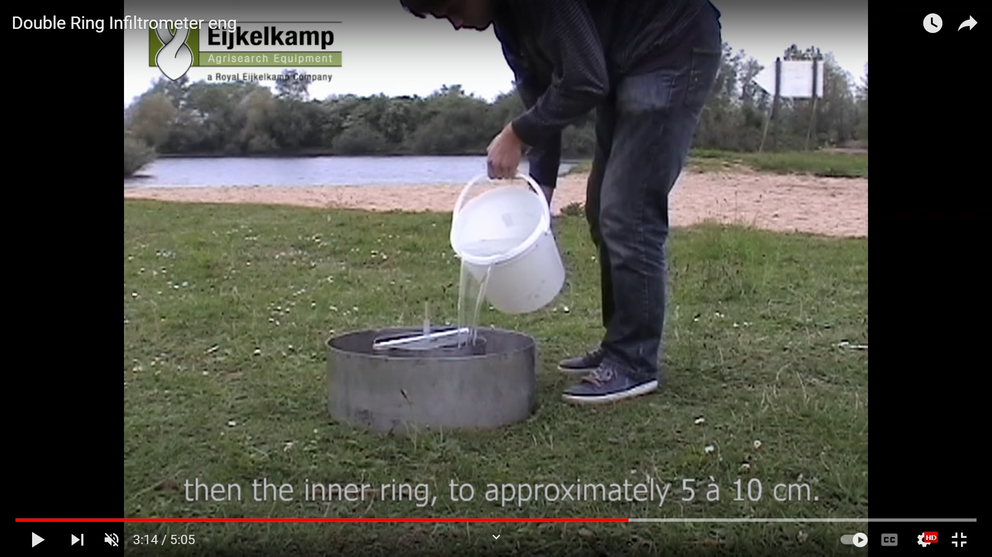

|  |
| --- |
|  |
|  |
|  |
|  |

Pop up question:

Why water level in both rings should be equal to minimize —----

1. **Later flow**
2. Longitudinal flow

5) start the stopwatch once the water is added equally into both the rings up-to the marked level. And note Down the water level readings after smaller intervals of time.

|  |
| --- |
|  |
| Edit -show blue colour in double ring |
|  |
|  |

### Table 1 soil surface with Grass Land

| Time change,  △T(min) | Initial Water level in the inner ring, H (cm) | Amount of water added to bring to the original level (cm) | Final Water level in the ring after adding water | Height change  △H (cm) | Infiltration  rate,  I (cm/min) | Cumulative infiltration amount (cm) |
| --- | --- | --- | --- | --- | --- | --- |
| 1 | 20.0 |  | 17.1 | 2.9 | 2.9 | 2.9 |
| 1 | 17.1 |  | 14.3 | 2.8 | 2.8 | 5.7 |
| 2 | 14.3 |  | 9.7 | 4.6 | 2.3 | 8.0 |
| 5 | 20 | 10.3 | 10 | 10 | 2.0 | 10 |
| 5 | 20 | 10 | 11 | 9 | 1.8 | 11.8 |
| 5 | 20 | 9 | 11.5 | 8.5 | 1.7 | 13.5 |
| 5 | 11.5 | - | 3.6 | 7.9 | 1.58 | 15.08 |
| 5 | 20 | 16.4 | 12.6 | 7.4 | 1.48 | 16.56 |
| 5 | 12.6 | - | 5.6 | 7.0 | 1.40 | 17.96 |
| 5 | 20 | 14.4 | 13.3 | 6.7 | 1.34 | 19.3 |
| 5 | 13.3 |  | 7.2 | 6.1 | 1.22 | 20.52 |
| 5 | 7.2 |  | 1.7 | 5.5 | 1.1 | 21.62 |
| 5 | 20 | 18.3 | 15 | 5.0 | 1.0 | 22.62 |
| 5 | 15 |  | 10.5 | 4.5 | 0.9 | 23.52 |
| 5 | 10.5 |  | 6.1 | 4.4 | 0.88 | 24.4 |

Accumulated infiltration depth= 24.4 cm

Average infiltration depth= 1.63 cm/min

Repeat the experiment in trail 2 for another soil surface condition

Table 2. Measurement of water infiltration using the double-ring infiltrometer method soil surface with barren land

| Time change,  △T(min) | Initial Water level in the inner ring, H1 (cm) | Amount of water added to bring to the original level (cm) | Final Water level in the ring after adding water H2 (cm) | Height change  △H (cm) | Infiltration  rate,  I (cm/min) | Cumulative infiltration amount (cm) |
| --- | --- | --- | --- | --- | --- | --- |
| 1 | 20.0 |  | 17.9 | 2.10 | 2.10 | 2.10 |
| 1 | 17.9 |  | 15.99 | 1.91 | 1.91 | 4.01 |
| 2 | 15.99 |  | 12.39 | 3.6 | 1.80 | 5.81 |
| 5 | 12.39 |  | 3.84 | 8.55 | 1.71 | 7.52 |
| 5 | 20 | 16.16 | 12.4 | 7.60 | 1.52 | 9.04 |
| 5 | 12.4 |  | 5.65 | 6.75 | 1.35 | 10.39 |
| 5 | 20 | 14.35 | 13.95 | 6.05 | 1.21 | 11.6 |
| 5 | 13.95 |  | 8.90 | 5.05 | 1.01 | 12.61 |
| 5 | 8.90 |  | 4.25 | 4.65 | 0.93 | 13.54 |
| 5 | 20 | 15.75 | 15.60 | 4.40 | 0.88 | 14.42 |
| 5 | 15.60 |  | 11.40 | 4.20 | 0.84 | 15.26 |
| 5 | 11.40 |  | 7.8 | 3.60 | 0.72 | 15.98 |
| 5 | 7.8 |  | 4.55 | 3.25 | 0.65 | 16.63 |
| 5 | 15.45 |  | 12.55 | 2.90 | 0.58 | 17.21 |
| 5 | 12.55 |  | 9.7 | 2.85 | 0.57 | 17.78 |

Accumulated infiltration depth= 17.78 cm

Average infiltration depth= 1.18cm/min

Inference- vegetated grass land has a higher rate of infiltration than the barren land. Hence barren land generates excess surface runoff.

Post test assessment

6. If the potential infiltration of a watershed having a soil with fair pasture cover, is 10cm and rainfall is 12cm, direct runoff is

1. 22 cm
2. 3 cm
3. 5 cm
4. 7 cm

**Answer - C**

7.As the temperature increases, the rate of infiltration also increases.

1. Ture
2. False

**Answer - True**

8. Rate of infiltration determined by the infiltrometer is less than the one determined by rainfall simulator.

1. True
2. False

**Answer - False**

9) Which of the following is used in the laboratory measurement of infiltration?

1. Infiltrometer
2. Rainfall simulator
3. Tensiometer
4. Lysimeter

**Answer - B**

10. If the intensity of the rainfall is more than the infiltration capacity of the soil, then the infiltration rate will be

1. Equal to the rate of rainfall
2. Equal to infiltration capacity
3. More than the rate of rainfall
4. More than infiltration capacity

**Answer - B**

11. According to Horton, the equation of the infiltration capacity curve, is (where letters carry their usual meanings)

1. f =(-)
2. f =(-)
3. f =+ (-)
4. f =+ (-)

**Answer - a**